Identifying the Presence of Microplastics in Marine Environments
Learning modes:
Next Generation Science Standards (NGSS): PS1-1, PS2-6, LS2-4, LS2-6, LS2-7, LS4-8, ESS3-2, ESS3-4, ETS1-1, ETS1-2, ETS1-3, ETS1-4
Crosscutting Concepts- Cause and Effect, Scale/Proportion/Quantity, Systems and System Models
Goal: To understand the physical properties of plastics that contribute to their permanence in marine environments and our society’s consumption of plastics.
Objectives:
- Understand the specific density properties of plastics and how to isolate them from water and beach samples.
- Follow step by step instruction and use scientific lab equipment
- Identify the presence of microplastics in a marine water and a beach sand sample.

Background: The consumption of plastics has contributed to the persistence of it in marine environments where it photo-degrades but never disappears entirely.
“Plastics are a group of materials, either synthetic or naturally occurring, that may be shaped when soft and then harden to retain the given shape.” Plastics are composed of polymers which are substances made from many repeating units. For hundreds of years, plastics derived from naturally occurring substances such as tar, shellac, animal horn, amber, latex and cellulose have been used. “It was not until the global disruption caused by World War II, when natural sources of latex, wool, silk and other materials became difficult to obtain, that synthetics were mass produced. Synthetic rubber was needed for tires, and nylon was needed as a replacement for silk for parachutes.” Since then, the use of synthetic polymer plastics has exponentially increased. Plastic particles are used in everything from clothing, food wrappers, straws, even paper towels and toilet paper. Plastics have many important properties. They tend to be chemical resistant, can be both thermal and electrical insulators, and are very light in weight with significant degrees of strength. The problem with plastics begins when we look at the way plastics break down. Synthetic petroleum based plastics often exhibit photo-degradation. UV rays react with the polymers and break the chain connections creating ever smaller plastic particles. Microplastics are defined as plastics 5mm or smaller. Secondary sources of plastics pollution are from macroplastics which break down into microplastics fragments. Primary sources are “microbeads, a type of micro-plastic, [which] are very tiny pieces of manufactured polyethylene plastic that are added as exfoliates to health and beauty products, such as some cleansers and toothpastes.” Macro and microplastics permeate the environment as they never disappear, but simply getting smaller and smaller.
News articles and scientific studies are making headlines about the impacts on plastics in natural environments. Seabirds and whales have been found ashore emaciated or dead with their digestive systems blocked and full of plastic. Even oysters have been found with plastic particles in their bodies. Scientists are becoming alarmed at the effects of plastic on the environment. “Many people assume that if trash exists in the ocean, it must be that the fishing and shipping industries are to blame. But in fact, only 20% of the items found in the ocean can be linked to ocean-based sources, like commercial fishing vessels, cargo ships (discharge of containers and garbage), or pleasure cruise ships. The remainder (80%) is from land-based sources, like litter (from pedestrians, motorists, beach visitors), industrial discharges (often in the form of plastic pellets and powders), and garbage management (ill-fitting trash can lids, etc.). There is growing research about plastic debris being too small to be caught by existing filters being discharged by water treatment systems. This debris may take the form of microbeads (added to some personal care products as exfoliants) [that are] rinsed down drains, or synthetic fibers from clothing or other items that are laundered.”
New recycling methods are being researched to separate the different types of plastics from garbage and recycling. A combination of lowering personal plastic consumption and a more efficient sorting and reuse of plastics will ultimately help to slow and limit the plastic waste which pervades in the environment.
Methods:
Originally inspired by this video: https://youtu.be/FJ36Gt6Rn0k?list=PLD6RutLvLz_uaWh547MjcvoOhkuk-aTa5, the basic lab uses the principle of density floatation to separate less dense plastic polymers from denser sediment particles in marine sediment using a high-density salt solution. After doing a bit of research (and asking a chemistry high school teacher friend), it turns out that the max density achievable using NaCl is only 1.2 g cm-3. The third most commonly used plastic is polyvinyl chloride that has a density that is approximately 1.4.
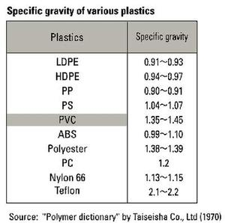
So, a NaCl solution would be ineffective. Researching other salts, ZnCl2 can attain a density of 1.5 when 972g is added to 1L H2O. If you read the attachment, NOAA has a particularly scientifically precise description of “Laboratory Methods for the Analysis of Microplastics in the Marine Environment: Recommendations for quantifying synthetic particles in waters and sediments”. However, lithium metatungstate can be expensive and the Wet Peroxide Oxidation FE (II) + hydrogen peroxide+ 75C is highly reactive which, while fun to watch, may not be the best choice for some classes. This might work as a demo instead of a classroom lab, but is not required in order to fulfill the goal of the main lab. The elimination of this step results in the sample containing natural organic material which will show up after the filtration process, but should not fluoresce.
My proposal is to simplify the lab to test for the presence of microplastics by making a solution of 1.5 cm-3 ZnCl2 to add to the sediment. Using a pipet, collect the floating material, run it through the microfilters provided. Put the filters under 40X magnification microscope and, while using a fluorescent lens, identify the glowing microparticles as plastics.
This experiment can be repeated using 1 L of seawater. Pour the water slowly through the filter and then place under the microscope. Using a fluorescent lens, the glowing particles are microplastics.

Conclusion: At the end of the lab, the next step is to have students understand where these particles are coming from and to address their choices in consumption of plastics.
- Have the students read the label on their jacket. Any cloth that lists acrylic, nylon, rayon, spandex and polyester as a material is made from a synthetic fiber. Have the students bring in their dryer lint to analyze. www.plasticpollutioncoalition.org lists 15 way to stop microfiber pollution.
- Many items that we think are made from natural products in fact have microplastic fibers added to them. When toilet paper or a paper towel is analyzed under the microscope, small plastic particles are illuminated.
- Microbead plastics are used heavily in the cosmetic industry. Often used as an abrasive material, they are commonly found in items ranging from toothpastes to facial scrubs. Beat the Microbead is a free app that allows you to scan the bar code or search for your personal cosmetic and check if a product has microbead plastics http://www.beatthemicrobead.org .
- Discuss the benefits and disadvantaged of limiting plastic consumption by the consumer vs recycling.

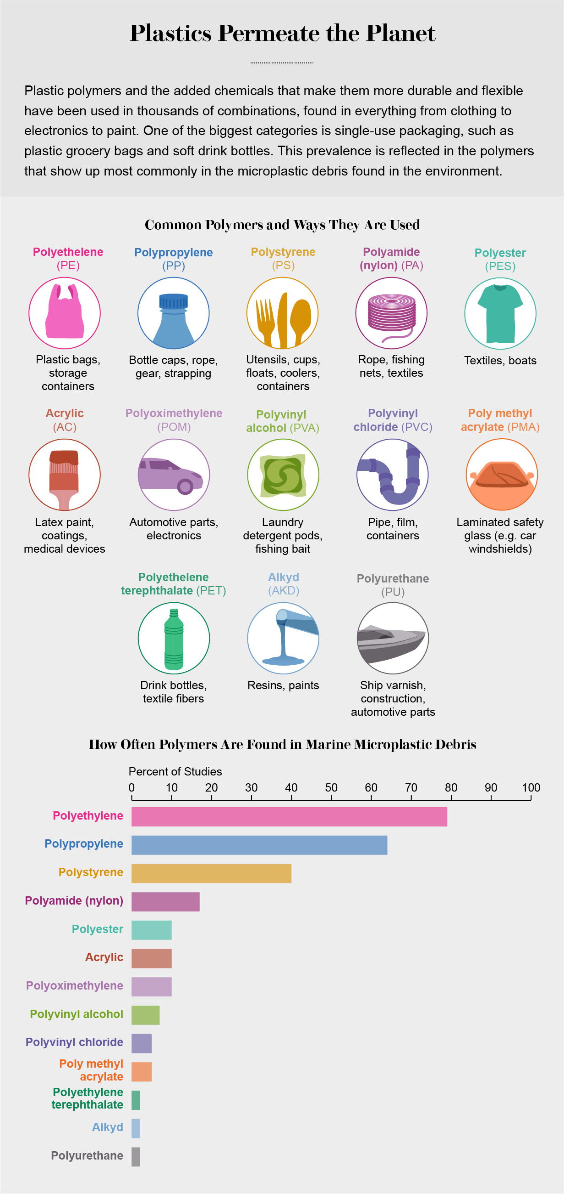

https://www.sciencehistory.org/science-of-plastics
https://www.sciencehistory.org/science-of-plastics
https://oceanservice.noaa.gov/facts/microplastics.html
https://youtu.be/nb7tbfjYu3o
https://www.coastal.ca.gov/publiced/marinedebris.html

