Project Whale Citizen Science
Kelp Adaptation
Learning modes:
Next Generation Science Standards (NGSS): PS2-3, LS1-2, LS1-5, LS2-5, LS2-6, LS2-7, LS4-3, LS4-4, LS4-5, ETS1-2, ETS1-3
Crosscutting Concepts: Cause and Effect, Structure and Function, Stability and Change
Goals:
Students will learn the functions of the structures of kelp and how they have various adaptations to live in harsh and varied marine environments.
Objectives:
- Understand the similarities of natural adaptation and human engineering to overcome the same forces.
- Discuss improvement to the current ROV design and possible adaptations for kelp.
- Demonstrate how to follow written scientific protocols and accurately use scientific equipment
- Identify and record commonly observed marine life
Background: Just as kelp have adapted to diverse forces in marine environments, submersible ROVs must be engineered to overcome the same forces.
Marine environments contain a plethora of conditions that are adverse for life; however, marine plants and animals have adapted unique systems in order to survive in these places. Our Monterey Bay is characterized by having cold water (12-15 degrees C as a seasonal surface temperature range), closest-to-shore deep ocean environments and a deep marine canyon more than a mile deep (1900m/6,230 ft). “Its diverse marine ecosystem also includes rugged rocky shores, wave-swept sandy beaches and tranquil estuaries.”
Macrocystis pyrifera, also known as giant kelp or giant bladder kelp, is not actually a plant, but a species of brown algae. It is common along the coast of the eastern Pacific Ocean from Alaska down to Baja California in Mexico. It can also be found near South America, South Africa, New Zealand, and southern Australia. As a part of the family Laminariaceae (kelps and relatives) and belonging to the class Phaeophyceae (brown algae), giant kelp grows using photosynthesis. Giant kelp has adapted to thrive in cooler ocean water temperatures that remain between 5- 20 degrees C. Giant kelp are perennials with a life cycle of up to 7 years depending on factors such as the severity of winter storms. Notably, giant kelp reaches an astonishing height of over 30m (100ft), making it the largest of the marine seaweeds. “They are known as kelp beds where there is no surface canopy and kelp forests where they form a canopy.”
Strong ocean currents in the Monterey Bay have pushed marine life to adapt. Just as plants and trees have roots to keep them fastened to the soil, kelps have adapted important specialized structures for the rocky material on the bay floor. In order to stay attached to the substrate, kelps have adapted to use holdfasts which act as anchors that maintain a grip on rocky substrates. This feature is so important that NOAA studies show: "Kelp survival is positively correlated with the strength of the substrate. The larger and stronger the rock on which it is anchored, the greater the chance of kelp survival. Winter storms and high-energy environments easily uproot the kelp and can wash entire plants ashore."
Photosynthesis is a critical food-producing feature for autotrophs like kelps. They require access to sunlight in order to synthesize the components they need for making food. While most plants use just their leaves, kelps can photosynthesize with all of their structures; however, the shape of the fronds or blades (similar to a plant’s leaves) is related to the specific location at which they are found. “Bull kelp exposed to rapidly moving water grow flat, narrow blades compared to those found in calmer, protected sites that grow undulate (ruffles), wide blades… [Giant kelp] exhibit similar differences in blade shape between fast and slow flow environments, suggesting the difference in blade shape is a common way to manage drag.” Drag is the “hydrodynamic forces imposed by tidal currents, waves, and surface shop." When too strong, it will break the kelp and damage or kill the kelp. So what is the benefit to wide ruffled blades? Wide ruffled blades separate themselves, limiting self-shading and increasing their exposure to sunlight. Nevertheless, ruffled edges create more drag and are therefore not found in areas with fast flow currents or churning tidal zones. Each adaptation has its benefits and limitations depending on the characteristics of the marine location. By having two distinct blade shapes, giant kelp increases the environments in which it can flourish.
So how does a kelp that grows at depths of 2 m to more than 30 m (6 to 90+ft) manage to reach the surface? Buoyancy is the key. Kelps have pneumatocysts which act as gas-filled flotation devices. These pneumatocysts hold a combination of oxygen, nitrogen, and carbon dioxide that has a lower density than seawater and therefore allows it to float.
In order to enable the kelp to reach such large lengths, the formation of a long stipe is required. Similar to a stem, a stipe is the structure that connects the holdfast to the pneumatocysts and blades (leaves). A kelp stipe must endure intense stresses from ocean currents before breaking. “The kelp stripe breaks at stresses (force per cross-sectional area) lower than other biomaterials such as wood and insect cuticle; however, it compensated for this low breaking strength by being stretchy… The stipe has an inner cortex made of cylindrical cells that bear most of the pulling (tensile) force. Similar to other plants, these cells are wound with a strong and inextensible cellulose fiber. The fibers wrap around in both left- and right-handed helices, creating an array that prevents cells from becoming too long and thin when pulled or too short and wide when compressed. This protects the cells from rupturing. The amount of shape change permitted depends on the angle between the fiber and the cell’s long axis: the smaller the fiber angle, the greater the cell width can change in relation to any alteration in the cell’s length. Vascular plants typically have an average fiber angle of 20˚, whereas bull kelp has an average fiber angle of 60˚. This means that the cells can stretch considerably along their length with relatively small changes in width. This large fiber angle plays an important role in the high extensibility of bull kelp."
The following articles describe specific kelp adaptations to various ocean conditions:
https://asknature.org/strategy/floats-keep-fronds-buoyant/#.W57Rhk2ovcs
https://asknature.org/strategy/blades-balance-drag-reduction-and-solar-exposure/#.W57Rk02ovcs
https://asknature.org/strategy/highly-stretchable-stipe-resists-breaking/#.W57RkU2ovcs
https://asknature.org/strategy/flexible-anchor-prevents-peeling/#.W57RmE2ovcs
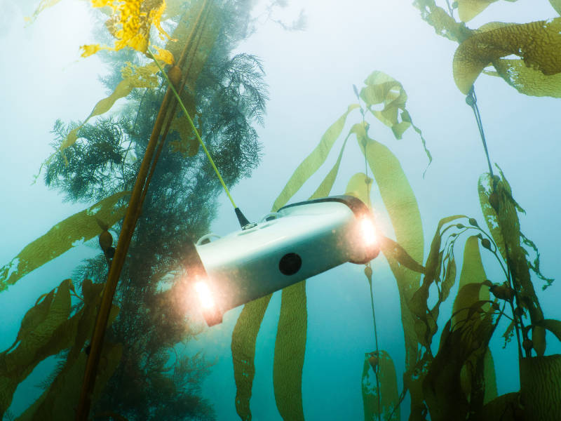
Methods:
Discuss how the Trident Underwater Drone ROV operates, what the controls do, what might be seen and narrate during the operation.
The Trident Underwater Drone has been engineered to adjust to the same forces that kelp undergo. It’s sleek design is to reduce water resistance/drag. This improves the submersible’s speedy two propulsion propellers and ability to work against the current. Additionally, as the kelp blades are smoother to avoid damaging other blades, so too is the drone side smooth so that the drone is less likely to become tangled in or damage marine life.
A 25 meter slightly positive buoyance in seawater tether has a breaking strength of 100kg and is Kevlar reinforced. It is high visibility yellow, easily distinguishable below the ocean surface.
Before putting the Trident into the water, it was tested with a hand vacuum pump. The center cylinder was pumped to 15mmHG and held there. If, after a few minutes, there was no loss of pressure then the seal is adequate.
Ballasting is the process by which weight is added to the ROV in order to provide stability. Ballasting the Trident is the key to a good dive performance. More ballast (weight) is required for salt water than fresh water. Why do you think that is? Hint: think density. Weight should be evenly distributed on the right and left and slightly biased toward the front in order to create the proper center of gravity. The ideal is to have a neutrally buoyant vehicle so that it neither sinks nor floats. This was tested by adding weight one at a time.
ROV useful Specs: Trident Underwater Drone
ENVIRONMENTAL
OPERATING WATER TEMPERATURE RATING | -2°C to 40°C
STORAGE TEMPERATURE | 0°C to 25°C
CHEMICAL RESISTANCE | Seawater, Diluted Chlorine
PERFORMANCE
DEPTH RATING | 100 m [328 ft]
MAXIMUM SPEED | 2 m/s [3.89 kts / 7.2 kph / 4.47 mph]
Lights
NUMBER | 3 forward facing LEDs on each side
TOTAL LUMENS | 360
COLOR TEMPERATURE | 4000K
BREAKING STRENGTH | 100 kg, Kevlar reinforced
BUOYANCY | Neutrally buoyant in freshwater, slightly positive in seawater
FEATURES | High visibility yellow with wear-resistant polyurethane jacket
NAVIGATION | 3-axis magnetometer, 3-axis gyro, 3-axis accelerometer, cm-resolution depth sensor
Conclusion
Marine kelp is highly adapted to the environments that they grow in. Although ocean factors seem harsh, kelp has unique structures to overcome average ocean conditions. However, they remain susceptible to changing ocean conditions that are both directly and indirectly caused by humans. Through the exploration of understanding ocean forces and engineering concepts we may be able to come up with strategies for the preservation of fragile marine life. Future research may lead to the reintroduction of native species in areas that have had habitat rehabilitation.

https://montereybay.noaa.gov/intro/
http://marinebio.org/oceans/forests/
https://sanctuaries.noaa.gov/visit/ecosystems/kelpdesc.html
https://asknature.org/strategy/blades-balance-drag-reduction-and-solar-exposure/#.W577jU2ovcs
https://asknature.org/strategy/highly-stretchable-stipe-resists-breaking/#.W57RkU2ovcs

